WHA OB Ultrasound Guidelines

Outline
- Pregnancy Nomenclature for the First Trimester
- Pregnancy Location Nomenclature
- Pregnancy Nomeclature for Pregnancy loss
- Timing of routine fetal ultrasound exams
- Dating Criteria Parameters
- WHA Ultrasound Dating Flowsheet
- Indications for performing a 1st trimester fetal ultrasound
- Components of detailed 1st trimester anatomy ultrasound
- Components of limited 1st trimester anatomy ultrasound
- First trimester genetic screening algorithms
- Nuchal Translucency (76813)
- Indications for performing a detailed fetal anatomy ultrasound exam
- Indications for performing a fetal echocardiogram
- Components of the 76805 and 76811 anatomy surveys- Sub optimal follow up guide
- Components of 76811- Image Criteria
- Timing of Follow-up Evaluation of 2nd Trimester Suboptimally Visualized Anatomy
- Components of the routine evaluation of anatomy on follow-up exams
- Cervical Evaluation
- Second trimester aneuploidy markers
- Fetal growth restriction
- Suspected Skeletal Dysplasia
- Placenta, Membranes, and Fluid
- Monochorionic twins
- Fetal Infection Screening
- Ultrasound finding communication plan
- Common Scenario Workflow:
  - What is this Adnexal Finding in a Pregnant Patient Who Has an IUP?
  - Is it an OB or GYN Ultrasound? Patient Presents with +HCG with NO IUP
  - Evaluate for RPOC (known prior pregnancy loss or status post-delivery)
- Patient Centered Care - TOP

The basis for these recommendations are the NICHD, SMFM, AIUM, American College of Radiology, Society for Pediatric
Radiology, Society of Radiologists in Ultrasound Consensus statement and AIUM Practice Guideline for Performance of Obstetrical Ultrasound¹ and the 76811 Task Force Consensus Report on the Detailed Fetal Ultrasound^{2,3}. Please refer to these documents and the other cited references for more details.

Nomenclature
A Lexicon for First-Trimester US: Society of Radiologist in Ultrasound Consensus Conference Recommendations. Rogers et al. Radiology 2024; 312(2):e240122.
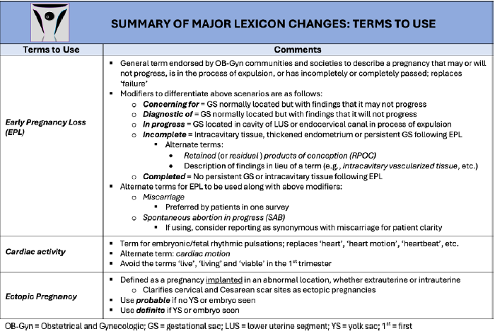
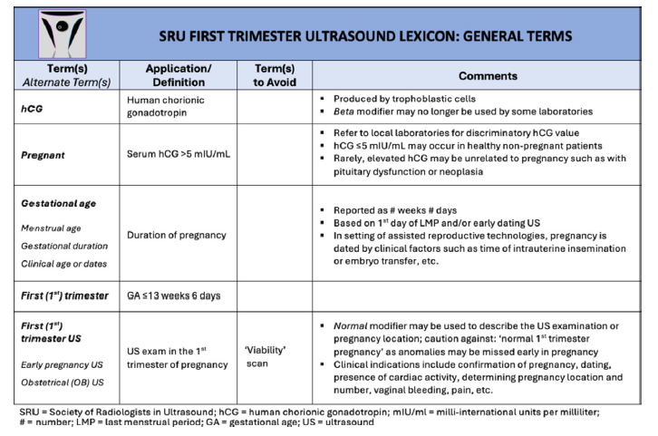

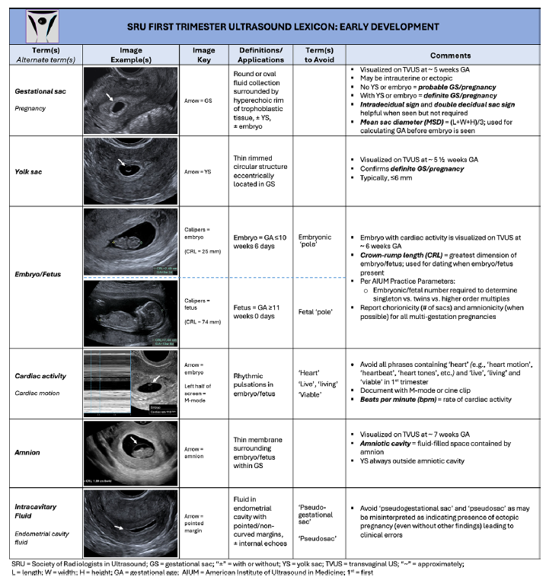

Pregnancy Location Nomenclature
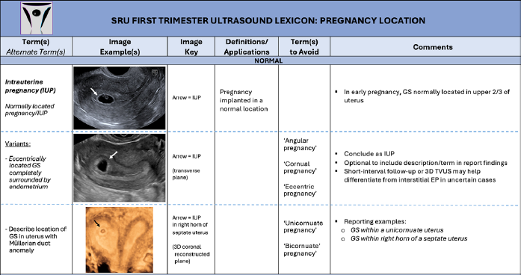

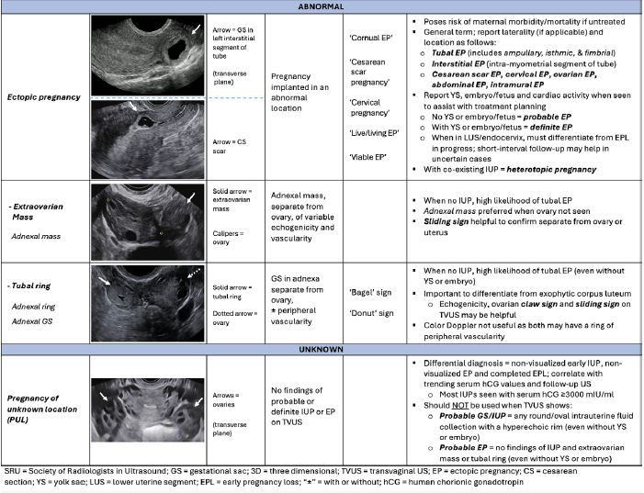

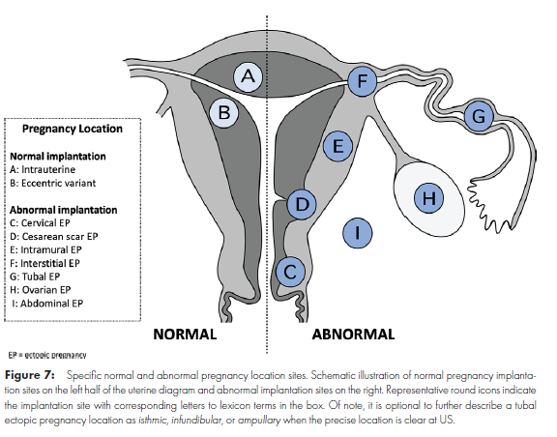
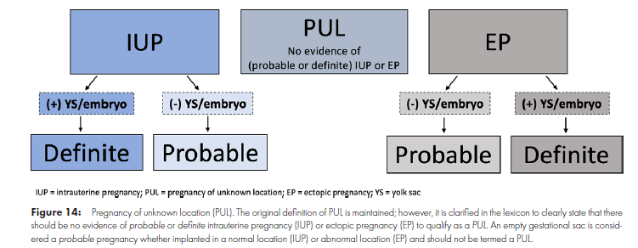

Early Pregnancy Loss Nomenclature
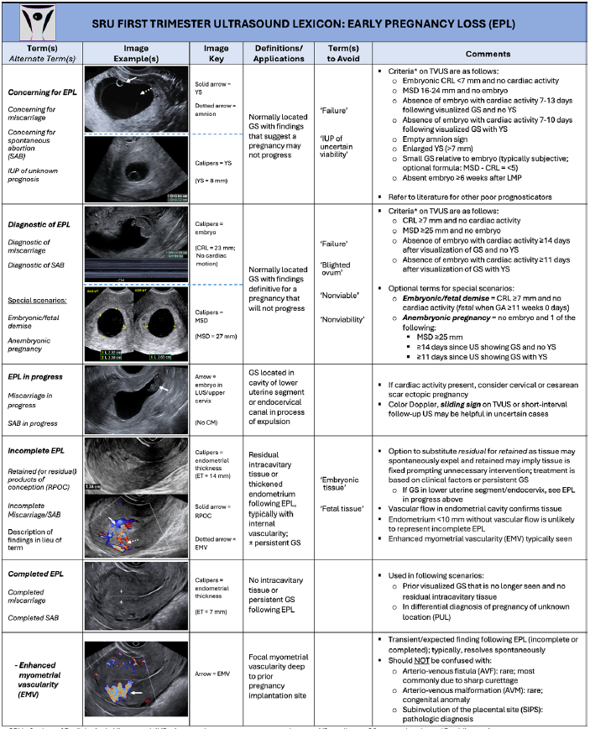

Timing of Routine Fetal Ultrasound Exams
- A first trimester 12-week dating/anatomy ultrasound exam is recommended but is optional if the pregnancy is otherwise well-dated and the patient does not desire genetic screening.
- A 20-week ultrasound exam is recommended to evaluate the fetal anatomy if it is not performed earlier for another indication. Pregnancy dating can also be accomplished at this time if an earlier exam is not performed.
Although it is acceptable to do the exam at 18-20 weeks, waiting until the later portion of this time period will minimize the likelihood of suboptimal visualized structures.
Dating Criteria Parameters
*Verbally confirm LMP date with the patient. Don’t rely on the LMP/EDD assigned in the EPIC or ordering comments in the tech worklist/EPIC order.

*Ask if this is an EXACT/CERTAIN LMP date or an APPROXIMATE/GUESSED/UNKNOWN LMP date? Has the patient been tracking LMP dates?

- Exact/Certain LMP date & Regular Menstrual Cycles – use guidelines for redating based on ultrasound table and flowcharts we currently utilize. (ACOG first tri dating & WHA ultrasound dating flowchart attachments)

- Exact/Certain LMP date & Irregular Menstrual Cycles – date based off CRL.

- Exact/Certain LMP date & Menstrual Cycle Lengths <25 or >31 days – date based off CRL. (Using an LMP date is dependent on the cycle falling between 25 - 31 days)

- Exact/Certain LMP date & Regular Menstrual Cycles & Lactating – date based off LMP.

- Exact/Certain LMP date & Irregular Menstrual Cycles & Lactating – date based off CRL.

- Approximate/Guessed/Unknown LMP date – date based on CRL.

- Prior formal outside ultrasound with CRL and FHR (viable pregnancy previously established and formal ultrasound report documented in the patient’s chart) – use EDD determined from that outside ultrasound. (Planned Parenthood and WHA BSUS are NOT considered a formal ultrasound)

- IVF – use embryo transfer date of 3 or 5 day fertilized embryo

*DO NOT use conception date – use CRL/LMP parameters above
*DO NOT use EDD determined by LMP corrected by cycle length; see #3 above

WHA Recommended Pregnancy Dating
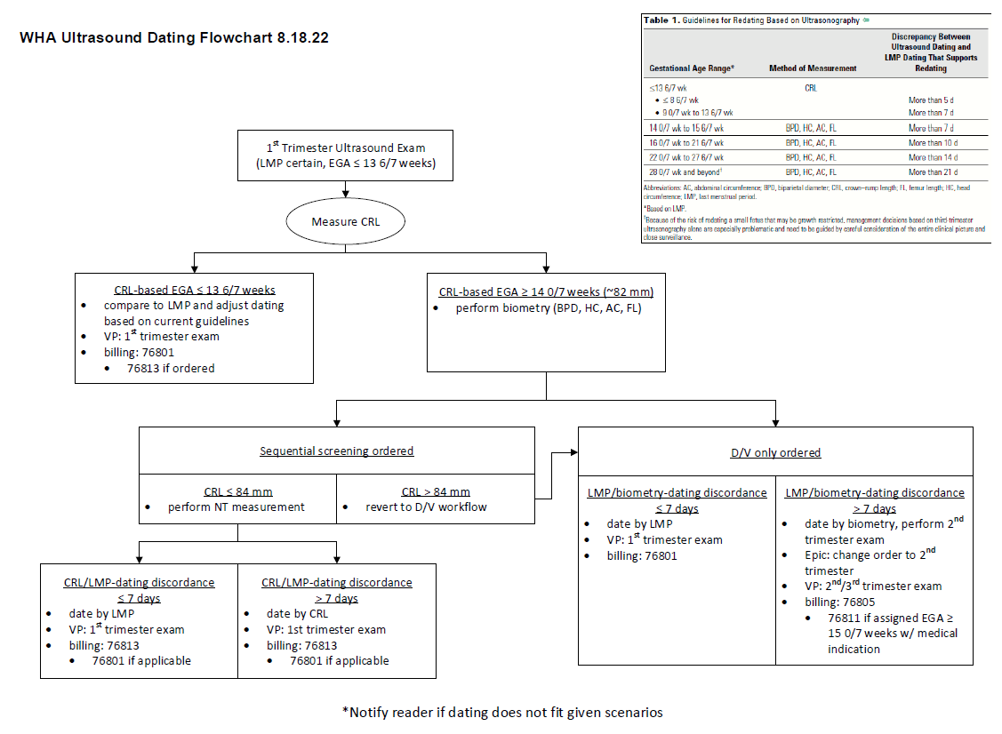

Indications for Performing a 1st Trimester Fetal Ultrasound (76801)
- Confirm the presence of an intrauterine pregnancy
- Diagnose or evaluate multiple gestations
- Evaluate a suspected ectopic pregnancy
- Evaluate vaginal bleeding
- Estimate gestational age
- Confirm cardiac activity
- As an adjunct to CVS, embryo transfer, or localization and removal of an IUD
- Assess for certain fetal anomalies in high-risk patients (e.g. anencephaly)
- Screen for fetal aneuploidy
- Evaluate suspected hydatidiform mole

Components of Detailed First Trimester Anatomy Ultrasound

COMPONENTS OF DETAILED FTA |  | IMAGE CRITERIA NEEDED TO PASS IMAGE
*Overview of fetal development. Midsagittal plane of the fetus in dorsoposterior position: CRL, head, face, NT, abdominal wall, bladder. *CRL. Midsagittal position in neutral position (chin and anterior neck < 90 degrees), Calipers placed at the outer border of the skin on the head and rump, measuring the maximal length of the fetus in a straight line. Avoid placement of calipers on the distal spine, posterior thigh, or limbs—average of three images.
Calvarium | Axial plane. Oval shape, normal contour, and ossification
Falx cerebri | Axial plane. Visualized, separating two hemispheres
Choroid plexus | Axial plane. Two echogenic separated plexuses visualized, often of unequal size and filling more than ½ of the lateral ventricles
Thalami | Axial and midsagittal planes (can be captured in images of other structures such as posterior fossa). Visualization of two separate thalami, with third ventricle in between
Posterior fossa | Midsagittal plane. Includes hypoechoic brainstem w/ echogenic posterior border (normal shape and position), anechoic 4th ventricle or IT, posterior echogenic choroid plexus of the 4th, and anechoic cisterna magna, occipital bone visualized and intact.
Brain stem | Posterior echogenic border, normal shape, not thickened, not kinked, and not thin
Midbrain | Midsagittal image, hypoechoic structure between thalami and brainstem
4th ventricle/intracranial translucency | Typical fluid space and echogenic lines, choroid plexus of fourth ventricle, and cisterna magna visualized
Cisterna magna | Future cisternal magna can be seen with the IT and choroid of the 4th ventricle in a more posterior axial/oblique angle (shaped like an hourglass)
Profile | Midsagittal plane. Includes forehead, nasal bridge, nasal bone, maxilla, and mandible to be complete
Nasal bone | Midsagittal and coronal w/in RNT
Retronasal triangle | Coronal plane. Nasal bones, maxillary processes, and anterior maxilla within the alveolar ridge visualized
Maxilla | Absence of maxillary gap on midsagittal view, coronal presence in RNT as lateral and inferior portions of the triangle
Mandible | Evaluation of mandible position on midsagittal views and standard mandibular gap on coronal imaging
Neck | Midsagittal view and evaluation for abnormal fluid collection or cystic hygroma
Nuchal translucency | Midsagittal plane. Skin edge & amniotic fluid visible, neutral position
Cardiac situs | Axial image at the level of the 4-chamber view (demonstrate heart and stomach situs) Axial image at the level of the 4-chamber view (demonstrate heart and stomach situs)
Cardiac position | Axial image at the level of the 4-chamber view with levocardia
Cardiac axis | Axial image at the level of the 4-chamber view showing axis pointing to the left. When suspecting an Abnormality, use a line from the spine to the anterior chest and then a second line through the interventricular septum to measure the angle. Around 45 +/- 15-20 degrees is normal
4 chamber view with color | Axial image demonstrating the presence of two distinct ventricles, almost equal size, two AV valves, no pericardial effusion, antegrade filling of two distinct ventricles on Color Doppler without significant atrioventricular valve regurgitation
3VTV with color | Axial image. V-shaped aorta and pulmonary artery on color Doppler with antegrade flow, and courses to the left of the trachea
Lungs | Axial image at the level of the 4-chamber view. Both lungs visualized without pleural effusions
Diaphragm demarcation | Coronal image slightly anterior to the spine and ribs
Anterior abdominal wall | Sagittal image at mid-abdomen demonstrating the abdominal wall and umbilical cord insertion, no fluid in the abdomen
Abdominal cord insertion | Same as above (Axial image) at mid-abdomen demonstrating abdominal wall and umbilical cord insertion). The bowel is slightly more echogenic than the liver and fills the abdomen at this level.
Stomach | Axial plane through upper stomach demonstrates left-filled stomach and right-sided liver
Liver | Axial images through the upper abdomen, right-sided, same image as the stomach. Presence of portal vein.
Kidneys | The coronal oblique plane of the mid-abdomen and pelvis demonstrates the right and left kidneys, which are slightly more echogenic than the bowel and may have fluid-filled renal pelvis. Color can be used to highlight renal arteries.
Bladder | Axial plane through lower abdomen/pelvis. Bladder filled, with length < 7 mm. Two umbilical arteries in color Doppler bordering the bladder
Color Doppler of perivesical umbilical arteries | Axial plane of the lower abdomen to demonstrate two umbilical arteries surrounding the bladder
Vertebral alignment | The midsagittal and posterior coronal plane (ideally viewed in the dorsoposterior position) demonstrates a complete spine, no interruption or deformity, and early ossification of vertebrae.
Skin edge (spine) | Midsagittal view in the dorsoposterior position ideally demonstrates intact skin covering the back
Arms | Axial-oblique plane image at the level of the chest; When performing a detailed exam, capture a parasagittal image of the humerus, radius, ulna, and hands.
Hands | Parasagittal oblique view of hands and fingers
Legs | Axial-oblique plane at the level of the pelvis; When performing a detailed exam, capture a parasagittal image of the femur, tibia, fibula, feet.
Feet | Parasagittal oblique view of feet
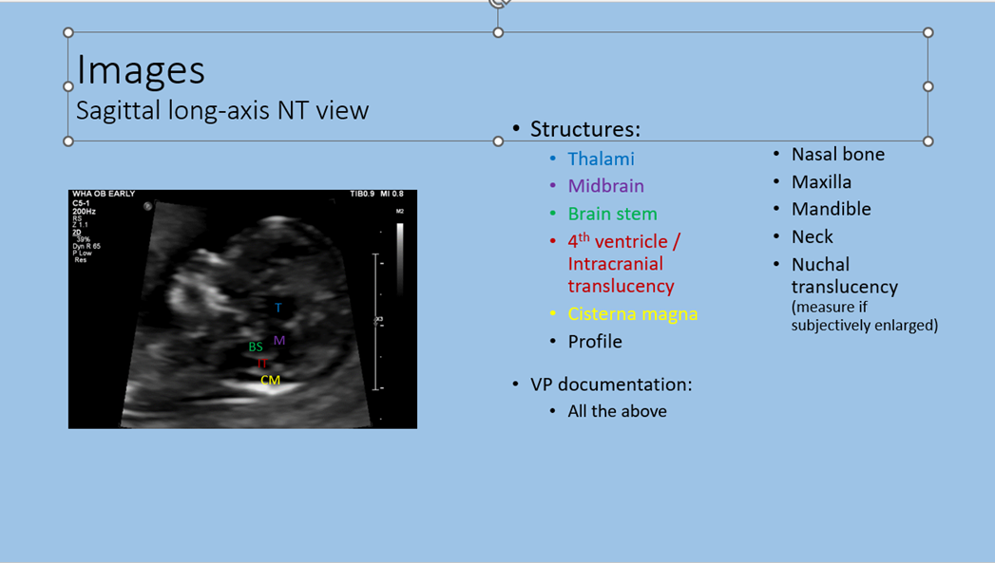

FIRST TRIMESTER ANATOMY (FTA) ASSESSMENT (see checklists on reverse side)
Limited FTA- all routine patients GA from 11 0/7 – 13 6/7 weeks
Detailed FTA- all patients GA from 12 0/7 – 13 6/7 weeks, who carry the following indications:
- Previous fetus or child with a congenital, genetic, or chromosomal abnormality.
- Known or suspected fetal anomaly or known growth disorder in the current pregnancy.
- Fetus at increased risk for a congenital anomaly, such as:
  - Maternal pre-gestational diabetes or gestational diabetes diagnosed before 24 weeks’ gestation,
  - Pregnancy conceived via assisted reproductive technology,
  - BMI ≥30,
  - Multiple gestation,
  - Abnormal maternal serum analytes,
  - Teratogen exposure,
  - First trimester nuchal translucency measurement ≥ 3.0 mm.
- Fetus at increased risk for a genetic or chromosomal abnormality such as:
  - Parental carrier of a chromosomal or genetic abnormality,
  - Maternal age ≥ 35 year at delivery,
  - Positive screening test result for aneuploidy,
  - Presence of sonographic aneuploidy marker on ultrasound exam,
  - First trimester nuchal translucency measurement ≥ 3.0 mm.
- Other conditions affecting the fetus, such as:
  - Congenital infections,
  - Maternal drug dependence (non-opioid, non-THC),
  - Isoimmunization,

Components of Detailed First Trimester Anatomy Ultrasound
Calvarium
Falx cerebri
Choroid plexus
Thalami & third ventricle
Ventricles & cortex
Posterior fossa- axial view
Brain stem
Midbrain
4th ventricle/intracranial translucency
Cisterna magna
Profile
Nasal bone
Maxilla
Mandible
Retronasal triangle
Neck – axial & sagittal
Nuchal translucency
Cardiac situs/position/axis
4 chamber view 2D & with color Doppler
3VTV with color Doppler
Lungs- Coronal or axial
Diaphragm demarcation
Ribs (shape/length/ossification)
Anterior abdominal wall - Sagittal
Abdominal cord insertion
Stomach- Axial
Liver
Portal Vein coursing away from stomach
Kidneys- Coronal
Bladder
Color Doppler of perivesical umbilical arteries
Vertebral alignment/skin edge- Sagittal
Four Extremities
Arms- 3 long bones
Legs- 3 long bones
Hands/Feet

Components of Limited First Trimester Anatomy Ultrasound
COMPONENTS OF LIMITED FTA
Calvarium
Falx cerebri
Choroid plexus
Nuchal Translucency
Cardiac situs
Cardiac position
Cardiac axis
Anterior abdominal wall
Abdominal cord insertion
Stomach
Bladder
Color Doppler of perivesical umbilical arteries
Arms
Legs

Common First Trimester Billing Scenarios

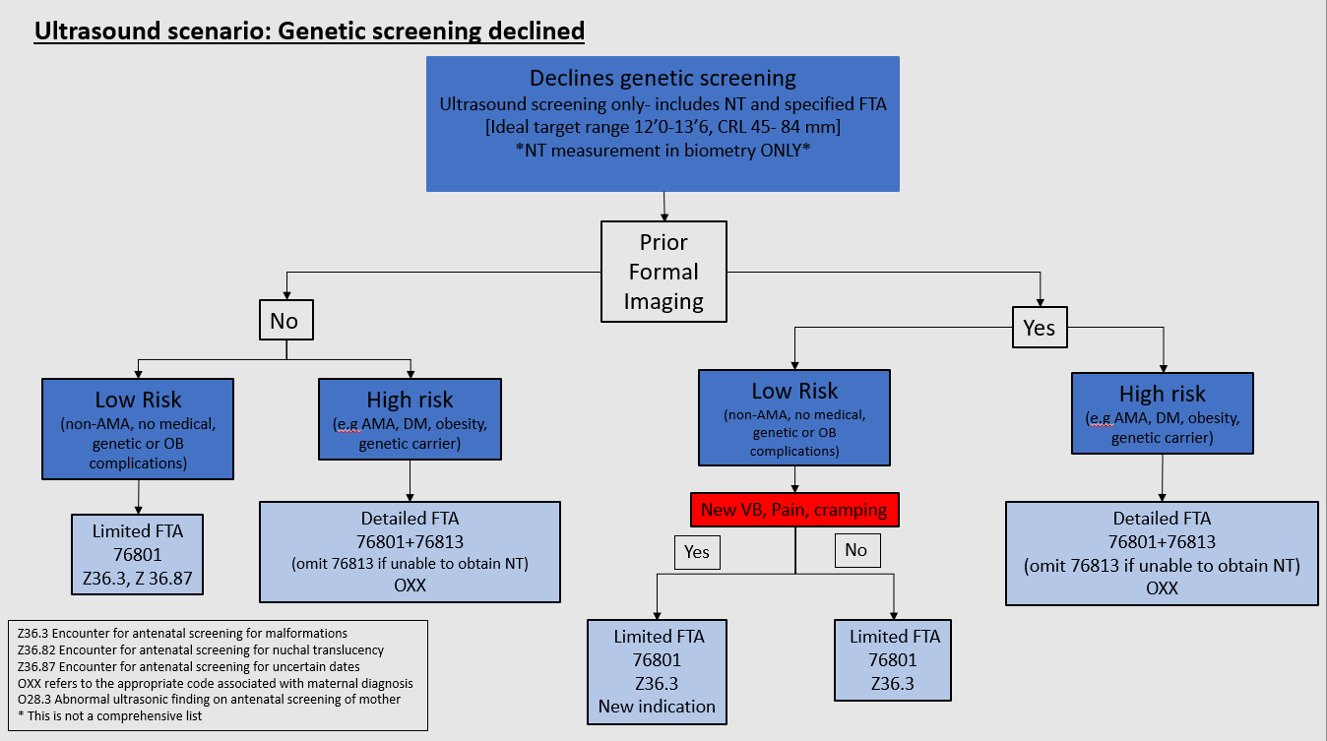

Nuchal Translucency (76813)
- Nuchal translucency measurements are obtained when the crown-rump length (CRL) falls between 45 - 84 mm.
- Risk based on NT findings:

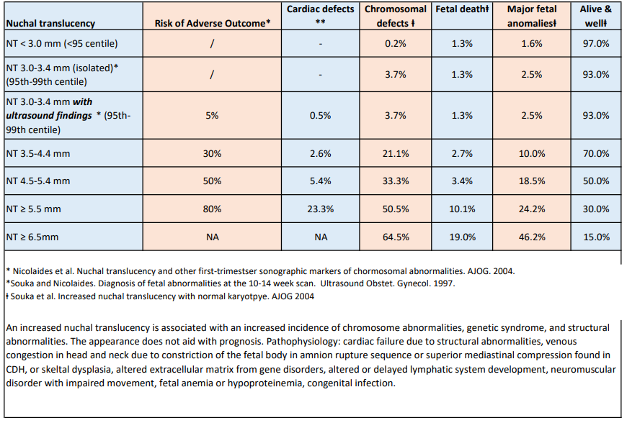

- Management of NT measurements:

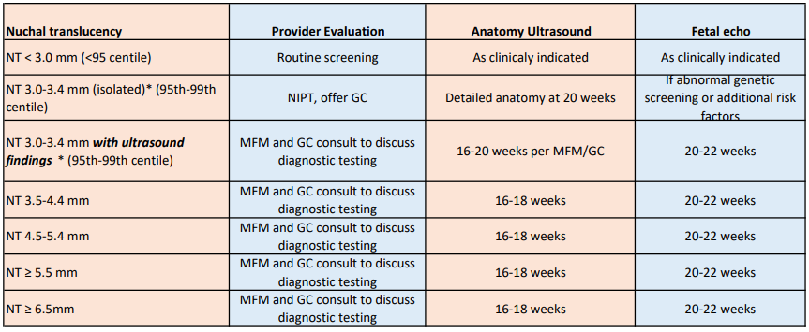*Please note that NT 3.0-3.4 without abnormality on detailed anatomy does not require fetal echo.

Indications for Performing a Detailed Fetal Anatomy Ultrasound Exam (76811)²
- Previous fetus or child with a congenital, genetic, or chromosomal abnormality.
- Known or suspected fetal anomaly or known growth disorder in the current pregnancy.
- Fetus at increased risk for a congenital anomaly, such as:
  - Maternal pregestational diabetes or gestational diabetes diagnosed before 24 weeks’ gestation
  - Pregnancy conceived via assisted reproductive technology
  - BMI ≥30
  - Multiple gestation
  - Abnormal maternal serum genetic screening
  - Teratogen exposure
  - First-trimester nuchal translucency measurement ≥ 3.0 mm
- Fetus at increased risk for genetic or chromosomal abnormality such as:
  - Parental carrier of a chromosomal or genetic abnormality
  - Maternal age ≥ 35 years at delivery
  - Positive screening test result for aneuploidy
  - Presence of sonographic aneuploidy marker on ultrasound exam
  - First-trimester nuchal translucency measurement ≥ 3.0 mm
- Other conditions affecting the fetus, such as:
  - Congenital infections
  - Maternal drug dependence (non-opioid, non-THC)
  - Isoimmunization
  - Oligohydramnios
  - Polyhydramnios

Indications for Performing a Fetal Echocardiogram (76825/76827/93325) (estimated risk ≥3%) Standard timing after anatomy ultrasound. Seattle Children’s Indications for Fetal Echo Referral. Brinks, Arya et al. 2023.
- Maternal indications
  - Familial inherited disorders, e.g. 22q11.2 deletion, Holt-Oram syndrome, poorly controlled phenylketonuria (genetic counseling is also recommended)
  - Metabolic diseases, e.g. type 1 DM, type 2 DM, GDM A2 diagnosed before 20 weeks
  - Teratogen exposure, e.g. anticonvulsants (topiramate, phenytoin, valproic acid, carbamazepine, lithium), vitamin A, among others
- Fetal indications
  - Abnormal cardiac screening examinations
  - First-degree relative of a fetus with CHD (sibling, mother, or father to this fetus)
  - Abnormal cardiac rate or rhythm
  - Extra-cardiac anomalies.
    - Omphalocele, duodenal atresia, congenital diaphragmatic hernia, neural tube defect, CNS malformations, AVM/Vein of Galen, CPAM/Lung mass, Rhabdomyomas, Sacrococcygeal tumors, VACTERL syndrome
  - Fetal hydrops
  - Monochorionic twins
  - Fetal aneuploidy, confirmed or highly suspected based on positive screening results
  - Incomplete anatomy ultrasound after two attempts
  - NT ≥ 3.5 mm

Components of the 76805 and 76811 anatomy surveys
Routine anatomy survey (76805)* |  | Anatomic structures for which visualization should be attempted for  all anatomy surveys | Detailed anatomy survey (76811)*
Marked as suboptimally  seen when not  adequately visualized | Follow-up imaging is  indicated in 2-  4 weeks when suboptimally seen** |  | Marked as suboptimally  seen when not  adequately visualized | Follow-up imaging is  indicated in 2-  4 weeks when suboptimally seen
 |  | profile | X
 |  | nasal bone measurement (15-22 wks) | X
X |  | lateral ventricles | X | X
X |  | choroid plexus | X | X
X | X | midline falx | X | X
X | X | cavum septi pellucidi | X | X
X | X | cerebellum | X | X
X | X | cisterna magna | X | X
 |  | cerebellar vermis/ 4th vent | X
X |  | upper lip | X | X
 |  | palate
 |  | maxilla | X
 |  | mandible | X
 |  | neck | X
 |  | nuchal fold (16-20 wks) | X
X | X | four chamber heart† | X | X
X | X | cardiac outflow tracts† | X | X
 |  | aortic arch, SVC/IVC, lungs | X
X |  | 3 vessel view | X | X
X |  | 3 vessel trachea view | X | X
 |  | video clip showing four chamber heart view and crossing outflow tracks | X
 |  | diaphragm | X
X | X | stomach | X | X
 |  | liver | X
X | X | kidneys | X | X
X | X | bladder | X | X
X |  | ventral wall | X | X
X |  | umbilical cord vessel number | X | X
X |  | umbilical cord insertion at placenta | X | X
X |  | spine | X | X
X |  | legs and arms | X | X
X |  | hands and feet | X | X
 |  | genitalia
 |  | fetal sex in twins | X | X
*Patients with a BMI <30 should undergo a routine fetal anatomic survey (76805) at 20-22 weeks. Patients with a BMI ≥30 should undergo a detailed fetal anatomic survey (76811).
**The clinical utility and cost effectiveness of follow-up for low-risk patients when parts of the fetal anatomy have not been well visualized in an otherwise normal survey has not yet been established. It may be reasonable to repeat the examination in 2–4 weeks, depending on the limitations and findings of the initial ultrasound study. Please refer to Timing of Follow-up Evaluation of 2nd Trimester Suboptimally Visualized Anatomy section that follows.

Components of Detailed (76811) /Image Criteria
COMPONENTS OF 76811 EXAM | IMAGE CRITERIA NEEDED TO PASS IMAGE
profile | Midsagittal view of the fetal face: includes the frontal bone, nasal bone, maxilla, and mandible
nasal bone measurement (15-22 wks) | Midsagittal view of the fetal face
lateral ventricles | Axial. Symmetrical and butterfly wing configuration, not normally parallel. Diameter of LV is measured inner edge to inner edge, perpendicular to the long axis of the ventricle at the glomus of the choroid plexus. < 10mm normal throughout gestation
choroid plexus | Axial image demonstrating both right and left choroid. Usually symmetrical in 2nd tri. Document the presence of cysts but do not measure unless distorting the lateral ventricle.
midline falx | Axial image of brain documenting midline linear echo which separates two cerebral hemispheres
cavum septi pellucidi | Axial image demonstrates the space between the septi pellucidi which is present between 18-37 weeks, often disappearing late in gestation. It is a box-like structure with bright linear echos forming the walls and an anechoic space between the linear echoes. It is situated between the frontal horns of the lateral ventricles. Cavum septi pellucidi et vergae is an anatomic variant where the CSP appears to extend posterior to the level of the colums of the fornix.
cerebellum | Axial and oblique view. Image the cerebellum, including CSP for correct image plane. Measure outer edge to outer edge
cisterna magna | Axial and oblique view including CSP, measure depth at the midline, from the posterior surface of the cerebellum to the inner table of the occiput. Normal ≤ 10 mm
cerebellar vermis | Axial and oblique, connects the two cerebellar lobes in the midline at the level of the 4th ventricle. It is also seen on sagittal images and can include an assessment of abnormal positioning
upper lip | (nasal structure). Angled coronal image of the alae (lateral nose), column, and nares
palate | Axial alveolar ridge view of bony palate
maxilla | Axial plan through the fetal face, cephalad to the mandible, capturing the bone inferior to the fetal nose, typically a V-shape configuration
mandible | Axial plane through the fetal face, cephalad to the neck, visualization of tooth buds, horseshoe appearance
neck | Mid-sagittal view. Axial views through thyroid and neck if goiter or mass suspected
nuchal fold (16-20 wks) | Axial image at the level of the cerebellum and cisterna magna. Measured 16-20 weeks
four chamber heart | Demonstrate axis, position, situs. Axis is usually 45 degrees (range 30-60), levocardia. Compare to stomach position. Demonstrate crux of the AV values and atrial and ventricular septa of the heart. Atrial and ventricles are approximately equal in cavity size and wall thickness. Image should include 2 pulmonary veins and evaluate for pericardial fluid in systole. Heart/Chest Circ ratio 0.55 +/-0.05
cardiac outflow tracts | LVOT: From the 4-chamber view, angle the side of the probe closer to the fetal right cephalad to encounter the LVOT and aortic valve. Include IVS.  RVOT: From a 4-chamber view, slide toward the fetal abdomen and angle toward the fetal right shoulder; RVOT with pulmonary valve courses anterior and across the aorta at a right angle. Branching of the main pulmonary artery occurs shortly after the pulmonic valve into the right and left pulmonary arteries
aortic arch, SVC/IVC, lungs | Aortic Arch: Rotate 90 degrees from the transverse 4 chamber view to a sagittal plane, which allows visualization of the aortic arch. Three head and neck vessels should be visible  SVC/IVC: right parasagittal plane, showing the SVC and IVC draining into the right atrium  Lungs: Image in axial plane, parasagittal if abnormal. Generally hyperechoic compared to the liver and decreases in echogenicity throughout gestation. Occupy 2/3-3/4 chest volume
3 vessel view | Transverse plane, scanning cranially from the 4ch view. Vessels listed in order from largest to smallest, Left > right; Main pulmonary trunk in direct communication with the ductus arteriosus; ascending aorta in transverse section; SVC is the smallest vessel. Trachea is visible in front of the spine.
3 vessel trachea view | Transverse plane, scanning cranially from the 3VV and left and caudal angulation from the transverse aortic arch. The ductal and aortic arches merge into the descending aorta with an acute angle between them and are located to the left of the spine and trachea. The superior vena cava is seen superior and right of the aortic arch
video clip showing four chamber heart view and crossing outflow tracks | Begin in the 4 chamber view, demonstrate opening and closing of mitral and tricuspid valves, including at least two pulmonary veins. Angle cephalad capturing the LVOT, RVOT, 3VV, and 3VTV.
diaphragm | Sagittal imaging. Thin, arched, hypoechoic band. Complete imaging includes anterior/posterior imaging through the diaphragm
stomach | Transverse axial image demonstrating the hypoechoic-filled stomach in the left upper quadrant, umbilical vein entering the abdomen and curving to the right, away from the stomach where it will enter the fetal liver
liver | Axial image through the upper abdomen. The fetal liver is large and extends across the upper abdomen with the left lobe anterior to the stomach
kidneys | Axial w/ dorsal position ideally and parasagittal imaging with color Doppler to demonstrate renal arteries. Measure renal pelvis and if abnormal, include 3D renal dimensions. External renal contour is lobular, cortex is intermediate in echogenicity. Medullary pyramids are arranged symmetrically around the renal pelvis. The AP diameter of the renal pelvis changes through gestation and should measure < 4 mm at GA < 28 weeks and < 7mm beyond 28 weeks
bladder | Transverse axial view in the lower pelvis showing the hypoechoic bladder and umbilical arteries coursing on the lateral margins of the bladder
ventral wall | Transverse axial image including fluid on either side of the umbilical cord to consider the abdominal wall and cord insertion site intact
umbilical cord vessel number | Viewed ideally at the bladder in transverse axial view or in cross section of the umbilical cord
umbilical cord insertion at placenta | Grey scale and color images to document cord insertion site and measurement from the lateral edge of the placenta
spine | Longitudinal and transverse axial images to demonstrate the cervical, thoracic, lumbar, and sacral spine. In longitudinal view: visualization of the parallel spinal echoes and normal kyphosis is seen. The skin edge should be visible with amniotic fluid between the fetus and uterine wall to adequately evaluate the skin edge. Transverse views document the vertebral bodies and caudal portion is confirmed by visualizing the ischial ossification centers
legs and arms | Document the upper and lower extremities. The fibula lies laterally and the tibia medially. The distal ends of the bones end at the same point. Proximally, the ulna is longer than the radius and the tibia is longer than the fibula
hands and feet | Documentation of the hand and digits with either closed or preferably open view. Image of the feet showing absence of anterior medial rotation
genitalia | Female genitalia assigned by visualization of the major and minor labia. Male genitalia assigned by visualization of the penis and scrotum

Timing of Follow-up Evaluation of 2nd Trimester Suboptimally Visualized Anatomy

Weeks | 15-16 | 17-18 | 19-21 | 22-28 | >28
Return | @ 20 weeks | 4 weeks | 2-3 weeks | 4-6 weeks | individualized
** Please repeat fetal biometry if the initial 2nd trimester exam is performed between 14’0 and 17’6 weeks and 4 weeks have lapsed between exams.

Components of the Routine Evaluation of Anatomy on Follow-up Exams

Anatomic structures for which visualization should be attempted for all follow-up ultrasounds if no prior anatomy evaluation has been performed within the  previous 6 weeks | Marked as suboptimally seen when not adequately visualized
upper lip | X
lateral ventricles | X
choroid plexus | X
midline falx | X
cavum septi pellucidi | X
cerebellum | X
cisterna magna | X
four chamber heart | X
cardiac outflow tracts | X
3 vessel view | X
3 vessel trachea view | X
stomach | X
kidneys | X
bladder | X
ventral wall | X
umbilical cord insertion at the placenta | X
spine | X

Cervical Evaluation
- Routine transabdominal cervical length evaluation is performed on exams done between 16-24 weeks’ gestation for pregnancy.
- Indicated transvaginal cervical length measurements are obtained between 16-24 weeks’ gestation in asymptomatic women in the following circumstances:
o Satisfactory images cannot be obtained by transabdominal approach,
o Cervical length on routine transabdominal imaging appears <30 mm,
o Patient has a history of prior singleton spontaneous preterm delivery.
  - Single TVCL at anatomy exam when history of PTB less than 37 weeks (generally will be ordered for 20 weeks)
  - Serial TVCL may be ordered if the preterm birth was before 32 weeks, refer to order to know if this is requested
* Fundal pressure is not recommended
* Include an image with color to detect fetal vessels near the internal os
- Transvaginal cervical length measurement is no longer routinely recommended for patients with prior cervical surgery (e.g. LEEP, conization), multifetal pregnancy, or uterine anomalies.
- Transvaginal cervical length measurement can also be utilized in women with preterm labor symptoms beyond 24 weeks’ gestation.

Second Trimester Aneuploidy markers⁵
- In AMA patients without prior screening, a detailed anatomy survey (76811) with no evidence of aneuploidy markers has been suggested to reduce the a priori risk by 50%.
- This theoretical risk reduction does not apply to patients with prior risk estimates based on first-trimester screening, sequential screening, or NIPT.

Echogenic intracardiac focus and Choroid plexus cysts
- Definition:
  - EIF: echogenic area within the heart with sonographic brightness equivalent to the nearby bone. Optimize image: with harmonics off, using a low transducer frequency, and the gain turned down.
  - CPC: echo lucent cystic structure within the choroid plexus with sharply circumscribed margins. Imaging. Measurement of the cyst size is not required unless distorting the lateral ventricle or surrounding brain tissue.
- Management:
  - When an EIF or CPC is seen on a routine anatomy exam, a detailed anatomic survey (76811) should be performed at that time or as a subsequent study.
  - When either an EIF or CPC is seen in isolation as part of a detailed anatomic survey, no further ultrasound follow-up is necessary.
- Aneuploidy:
  - Prior screening performed and low risk: when seen in isolation, no further aneuploidy risk adjustment is necessary, and the finding is considered a normal variant.
  - No prior screening performed: offer maternal serum screening or NIPT screening.

Urinary tract dilation (UTD) (previously pyelectasis)
- Definition: Renal pelvis diameter in a transverse AP plane of
  - ≥ 4.0 mm before 28 weeks’ gestation
  - ≥ 7.0 mm after 28 weeks’ gestation
  - Determine if UTD A1 or UTD A2-3 after 28 weeks
  - UTD A1: Urinary tract dilation, including central calyceal dilation
  - UTD A2: Urinary tract dilation with progression to include any of the following: peripheral calyceal dilation, dilated ureters, abnormal appearance of the renal parenchyma (thickness, echogenicity, presence of cysts), abnormal bladder appearance, and oligohydramnios.

- 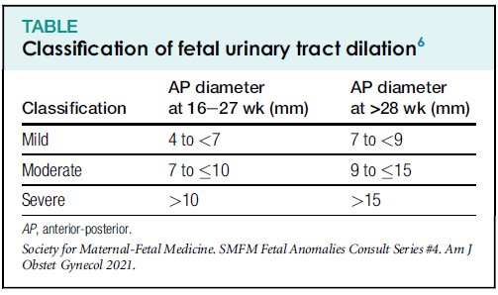
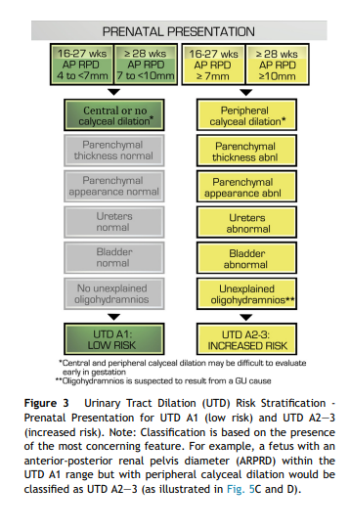
Multidisciplinary consensus on the classification of prenatal and postnatal urinary tract dilation (UTD classification system). Journal of Pediatric Urology (2014) 10, 982-999.

- Management:
  - When urinary tract dilation is seen on a routine anatomy exam, a detailed anatomic survey (76811) should be performed either at that time or as a subsequent study.
    - The report should comment on parenchymal appearance (normal or echogenic, presence of cysts or thickness), calyceal dilation (present or absent), ureteral dilation (present or absent), bladder assessment, and amniotic fluid volume.
  - A follow-up evaluation of the fetal kidneys is recommended at 32-34 weeks’ gestation.
    - If persistent UTD ≥ 7.0 mm is noted at that time, either postnatal evaluation or prenatal consultation with pediatric urology may be recommended.
- Aneuploidy:
  - Prior screening performed and low risk: when seen in isolation, no further aneuploidy risk adjustment is necessary, and the finding is not reported as a soft marker for aneuploidy.
  - No prior screening performed: offer maternal serum screening with NIPT.

Nuchal fold thickening
- Definition: nuchal fold thickness ≥ 6.0 mm between 16-20’6 weeks of gestation
- Management:
  - When nuchal thickening is seen on a routine anatomy exam, a detailed anatomic survey (76811) should be performed at that time or as a subsequent study.
  - When seen in isolation as part of a detailed anatomic survey with a normal four chamber heart and cardiac outflow tracts, no further ultrasound follow-up is required.
- Aneuploidy:
  - Prior screening performed and low risk: when seen in isolation, no further aneuploidy risk adjustment is necessary, and the finding is not reported as a soft marker for aneuploidy.
  - No prior karyotype or NIPT: offer formal genetic counseling

Echogenic Bowel
- Definition: echogenic bowel as bright as nearby bone. Optimize image: with harmonics off, using a low transducer frequency, the gain turned down.
- Management:
  - When echogenic bowel is seen on a routine anatomy exam, a detailed anatomic survey (76811) should be performed at that time or as a subsequent study.
  - Consider screening for cystic fibrosis and CMV
  - A follow-up evaluation of fetal growth is recommended at about 32 weeks of gestation.
- Aneuploidy:
  - Prior screening performed and low risk: when seen in isolation, no further aneuploidy risk adjustment is necessary, and the finding is not reported as a soft marker for aneuploidy.
  - No prior karyotype or NIPT: offer formal genetic counseling

Shortened femur or humerus
(This section pertains to isolated shortening of the femur or humerus; see skeletal dysplasia for other scenarios)
- Definition:
  - Genetic screening tool for Down syndrome risk assessment which utilizes a calculated comparison of the sonographically measured long bone and BPD to assess the fetal Down syndrome risk. The provider will calculate the measured-to-expected (M/E) ratio (based on BPD and long bone length). Values of <0.91 for femur and <0.89 for humerus are associated with an increase in risk for fetal Down syndrome.
  - Calculation of M/E ratio to be triggered when the femur length or humerus length measures less than the 5th%ile for gestational age.
- Management:
  - When femoral or humeral shortening is suspected on a routine anatomy exam, a detailed anatomic survey (76811) should be performed at that time or as a subsequent study.
  - A follow-up evaluation of fetal growth is generally recommended at approximately 32 weeks’ gestation. (See section on skeletal dysplasia screening below).
- Aneuploidy:
    - LR reported as 1.2-2.2 for shortened femur and 2.5-5.8 for shortened humerus, respectively o Prior screening performed and low risk: when seen in isolation, no further aneuploidy risk adjustment is necessary, and the finding is not reported as a soft marker for aneuploidy.
    - No prior screening performed: offer maternal serum screening or NIPT screening.
    - Follow-up ultrasound in the third trimester to evaluate fetal growth, with consideration for risk for skeletal dysplasia.

Fetal Growth⁷
- Fetal growth restriction (intrauterine growth restriction IUGR)
o Definition:
  - EFW <10th %tile, or AC <10th %tile for gestational age using Viewpoint software as a reference source
- Management:
  - Additional evaluation such as umbilical artery Doppler S/D ratios and BPP should be considered based upon the clinical situation (e.g., gestational age). Perform Doppler evaluation on all patients and attempt BPP for patients > 28 weeks.
  - Consider aneuploidy testing if <28 weeks’ gestation
  - Refer to NWP antenatal testing guidelines for recommendations for subsequent management and surveillance
- Concerning growth
  - Definition: discrepancy of >10 days difference at the time of the anatomy survey between US EGA and established EGA (in an otherwise well-dated pregnancy)
  - Management:
  - Follow-up growth ultrasound in 4 - 6 weeks
  - Consider aneuploidy testing if < 24 weeks’ gestation
- Growth discordance in twins
  - Definition: discordance of >20%
  - Management: Weekly antenatal fetal testing to begin at 32 weeks gestation

Suspected fetal skeletal dysplasia
- Definitions:
- Fetal skeletal dysplasia (SD) is a broad category of fetal conditions impacting the skeletal system. They can be hereditary or de novo (presenting for the first time in this pregnancy). The type of SD depends on the fetal findings, and multiple algorithms have been created. Prenatal diagnosis aims to categorize the type of SD and determine if it will impact fetal/newborn survival (lethality).

- There are generally two categories:
- Complex. Multiple skeletal abnormalities which may include:
  - Limb agenesis: abnormal long bone length (proximal, distal or both)
  - Hypomineralization
  - Fractures
  - Head calvarium contour is irregular (clover leaf, hypomineralized, micro/macrocephaly)
  - Facial anomalies: frontal bossing or micrognathia, cleft lip or palate
  - Thoracic abnormalities: small fetal chest or length, barrel-shaped or large heart to chest size
  - Other bone findings: Irregular shape or curvature, abnormal clavicles, spine anomaly, pelvic bone abnormality
- Isolated. Incidental finding of femur or humerus less than the 5th percentile for gestational age. No evidence of fracture, hypomineralization, bone curvature, small chest/large heart, and calvarium contour normal. This finding can increase the risk for fetal Down syndrome depending on the M/E ratio.
- Management:
  - Isolated: Complete standard fetal biometry. If the FL or HL is < 5th%, upgrade to a detailed anatomy exam and add measurement of chest circumference at the 4-chamber view and foot length to aid MFM to predict severity (post processing is feasible with our standard protocol views).
    - Correlate with genetic screening or offer NIPT.
    - MFM consult and follow-up fetal growth at 28 weeks
  - Complex. Complete detailed anatomy and skeletal survey to narrow the differential diagnosis. MFM consultation for counseling and recommend amniocentesis to inform diagnosis and prognosis.
    - Detailed evaluation of the skeletal system includes measurement of all the long bones, assessment of the calvarium, measurement of the clavicles, assessment of the spine and pelvic bones, evaluation of the fetal face, thoracic circumference, and evaluation of short ribs.
    - Follow-up monthly for fetal growth. Some structures will demonstrate larger bone growth lag in the third trimester.

Placenta, Membranes, & Fluid

Placenta previa
- Definitions:
- Placenta previa: any portion of the placenta at or covering the internal cervical os
- Low-lying placenta: the inferior edge of the placenta residing <20 mm from the internal cervical os
The descriptive terms marginal previa and partial previa should no longer be used
- Management:
      - Transvaginal imaging to describe the appearance and location of the placenta
      - Follow-up evaluation of placental position is recommended at 32-36 weeks’ gestation in asymptomatic patients with either placenta previa or placenta location ≤10 mm from the internal os.

Vasa previa
- Definition:
- Type 1: Velamentous cord insertion and fetal vessels that run freely within the amniotic membranes overlying the cervix or in close proximity to it (2 cm from internal cervical os).
- Type 2: Succenturiate lobe or multilobe placenta (bilobed) with fetal vessels crossing over or in close proximity to the cervix (2 cm from internal cervical os).
- Management:
- Routine ultrasound evaluation of the lower uterine segment and placenta should be performed to assess the location of the placenta and its relationship with the internal cervical os.
- The umbilical cord insertion site should also be documented.
- Color documentation in the lower uterine segment and cervix should be conducted to exclude fetal vessels.
- Transvaginal ultrasound should be utilized to describe the relationship between the placenta and the cervix in cases of a low-lying placenta or vascularity noted near the cervix. Pulse wave Doppler of any visualized vessels should be used to document maternal versus fetal waveforms.
- Follow-up imaging at 28 and 32 weeks is often planned to assess for resolution.
- TVCL may also be used to assess for preterm birth risk.

Velamentous cord insertion
- Definition:
- The umbilical cord inserts into the amniotic membrane before entering the placenta. This finding is associated with an increased risk for fetal growth abnormality as well as intrapartum fetal heart rate tracing changes. A vasa previa should be excluded if the placenta is low lying.
- Management.
  - Use color to document the cord insertion in sagittal and transverse and evaluate the LUS for vasa previa if the cord insertion site is near the cervix (within 2 cm).
  - Recommend a fetal growth ultrasound at 32 weeks and clinically appropriate labor management.

Marginal cord insertion

- Definition:
  - A marginal cord insertion is defined as an insertion site lying within 20 mm of the placental edge. Marginal cord insertion with a distance less than 10 mm from the placental edge carries a higher risk for fetal growth restriction in the third trimester.
- Management
  - A fetal growth ultrasound is recommended at 32 weeks of gestation for cord insertion < 10 mm. Without fetal growth abnormality, no further work-up or monitoring is recommended.
  - Marginal cord insertion with a distance of 10-20 mm from the placental edge is at low risk for fetal growth restriction and does not require further follow-up.

Placenta accreta spectrum
- Definition:
  - Consideration for placenta accreta should occur in the setting of a placenta previa, prior uterine surgery (D&C, cesarean), and Asherman syndrome. Sonographic markers for placenta accreta spectrum include placenta previa, loss of the normal hypoechoic "clear" zone between the placenta and myometrium, myometrial thinning (less than 1 mm), placental lacunae, subplacental hypervascularity, and bridging vessels between the placenta and myometrium. Additional findings of a placental bulge, bladder wall interruption, exophytic mass, and uterovesical hypervascularity may be present/absent.
- Management:
  - MFM consultation and serial ultrasound follow-up ultrasound is recommended, typically at 4–6-week interval for further evaluation and delivery planning.

Amniotic Fluid Volume Assessment⁸
- Definition (Amniotic fluid volume assessment in singleton pregnancies) *
o 14 0/7 - 23 6/7 weeks’ gestation: use single maximum vertical pocket (MVP)
  - Oligohydramnios: MVP < 2.0 cm
  - Normal: MVP 2.0 - 7.9 cm
  - Polyhydramnios: MVP ≥ 8.0 cm
- Mild: MVP 8.0 - 11.9 cm
- Moderate: MVP 12.0 - 15.9 cm
- Severe: MVP ≥ 16.0 cm
o ≥ 24 0/7 weeks’ gestation: use formal amniotic fluid index (AFI)
- Oligohydramnios: AFI < 5.0 cm
- Borderline/Low normal: AFI 5.0 - 7.9 cm
- Normal: AFI 8.0 - 23.9 cm
- Polyhydramnios: AFI ≥ 24.0 cm
  - Mild: AFI 24.0 - 29.9 cm
  - Moderate: 30.0 - 34.9 cm
  - Severe: ≥ 35.0 cm
* All multifetal pregnancies utilize the single MVP method, regardless of gestational age

- Management:
o Oligohydramnios
▪ MVP < 2.0 cm @ 14 0/7 - 23 6/7 weeks: individualized care per MFM
▪ AFI < 5.0 cm @ ≥ 24 0/7 weeks:
- MVP ≥ 2.0 cm
    - < 36 0/7 weeks’ gestation: weekly BPPs
    - 36 0/7 - 37 6/7 weeks’ gestation: twice weekly BPPs
- MVP < 2.0 cm
    - < 36 0/7 weeks: individualized care per MFM
    - 36 0/7 - 37 6/7 weeks’ gestation: delivery

o Borderline/Low normal AFI: repeat AFI in 1 week – repeat weekly if persistent
o Polyhydramnios⁶
- MVP ≥ 8.0 cm @ 14 0/7 - 23 6/7 weeks’ gestation detailed anatomy evaluation
- Mild: AFI 24.0 - 29.9 cm @ ≥ 24 0/7 weeks’ gestation
  - evaluation of anatomy per routine follow-up guidelines with specific attention to nose/lips, stomach, and CNS
  - evaluation of fetal growth if not previously performed in last 4 weeks
  - antenatal fetal surveillance is not required for mild idiopathic polyhydramnios in absence of other risk factors
- Moderate - Severe AFI ≥ 30 cm @ ≥ 24 0/7 weeks’ gestation
  - detailed fetal anatomic survey
  - evaluation of fetal growth if not previously performed in last 4 weeks
  - consider amniocentesis for aneuploidy
  - < 32 weeks: Repeat AFI q 2-3 weeks, growth q 4-6 weeks
  - ≥ 32 weeks: Weekly BPP, growth q 4-6 weeks

Monochorionic Twins
• Definition:
- Monochorionic diamniotic twins are identified early within a single gestational sac containing two amniotic sacs. Later in the first trimester, a thin intertwin membrane with T sign is visualized.
- Monoamniotic twins develop from a single yolk sac and have no intertwin membrane visualized.
- Management:
o Every 2-week evaluation for twin-to-twin transfusion syndrome (TTTS) starting at 16 weeks’ gestation until delivery
- Amniotic fluid maximum vertical pockets for each twin
- Visualization of fetal bladders
- Fetal biometry every 4 weeks
- Weekly antenatal testing starting at 32-33 weeks’ gestation if concordant
- Routine use of Doppler studies of the umbilical artery or middle cerebral artery is not current recommended but planned for review by MFM

Fetal infection screening

Definition:

Common fetal infections in pregnancy include cytomegalovirus and syphilis. Less commonly, infections such as toxoplasmosis, herpes, and rubella may be diagnosed.

Findings may include fetal growth restriction and microcephaly, echogenic foci in the abdomen, liver, or brain, hepatomegaly, ventriculomegaly, abdominal ascites, pericardial effusions, hydrops, echogenic bowel, bone abnormalities.

Management: Detailed ultrasound assessment to include evaluation of the liver, brain, bowel.

Ultrasound Finding Communication Plan
ULTRASOUND FINDING | DIRECTLY CALL MFM | NOTIFY MFM VIA TEAMS IM | SONO COMMENT IN VP ONLY
Major structural anomalies - (ANY) New Diagnosis | X
FGR- New diagnosis | X
Abnormal antenatal testing (BPP score <8/8) | X
Isolated Fetal measurement < 5th%ile (HC/FL/HL) | X
Follow-up FGR |  |  | X
Embryonic or fetal demise | X
Ectopic pregnancy | X
Isolated EIF - prior low-risk screening |  |  | X
Isolated EIF - no prior screening | X
CPC - prior low risk screening |  |  | X
CPC- no prior screening | X
Echogenic bowel | X
Multiple soft markers of aneuploidy | X
Any NT >3.0 (95th-99th centile) | X
Placenta previa in 2nd trimester |  |  | X
Placenta previa in 3rd trimester |  |  | X
Low-Lying placenta |  |  | X
Suspected Vasa Previa | X
Placenta accreta spectrum | X
Placental lakes |  |  | X
Velamentous cord insertion |  |  | X
Marginal cord insertion |  |  | X
EFW > 90% |  |  | X
“Macrocephaly” |  |  | X
Mild Polyhydramnios (24.0-29.9cm) |  |  | X
Moderate or Severe Polyhydramnios (>30cm) | X
Borderline low AFI (5-8cm) |  |  | X
Oligohydramnios | X
Urinary tract dilation- >7mm any GA | X
Urinary tract dilation- < 7mm any GA |  | X
Billing, coding, dating questions |  | X

What is this Adnexal Finding in a Pregnant Patient Who Has an IUP?
- EPIC order/Viewpoint exam remains an OB
- MFM reaches out to GYN reader by phone to review images
  - If GYN reader is unavailable, the MFM will request USC’s assistance > USC will communicate in teams channel and connect any available GYN reader with an MFM.
- MFM will finalize the exam after reviewing with the GYN reader; GYN readers name will be entered into the impression section of the report as a secondary reader/reviewer.
Viewpoint Title: GYN Reader
Comment: "The exam included findings which were reviewed with the GYN ultrasound reader, Dr. X. "

Is it an OB or GYN Ultrasound? Patient Presents with +HCG with NO IUP (includes suspected ectopic pregnancies and early pregnancies with bleeding)
- *Should be ordered as an OB
- Keep EPIC order and Viewpoint exam an OB
- Sonographer > keep patient in room or clinic until further instruction is provided by MFM
- MFM reaches out to GYN reader by phone to review images
  - If GYN reader is unavailable, the MFM will request USC’s assistance > USC will communicate in teams channel and connect any available GYN reader with an MFM.
- MFM will provide instructions to the sonographer for patient plan.
- MFM will finalize the exam after reviewing with the GYN reader; GYN readers name will be entered into the impression section of the report as a secondary reader/reviewer.

Evaluate for RPOC (known prior pregnancy loss or status post-delivery)
- *Should be ordered as a GYN
- Keep EPIC order and Viewpoint exam a GYN
- In the presence of RPOC and a stable patient, no acute symptoms from the patient, sonographer may release the patient and communicate findings via teams IM to the GYN reader of the day.
  - In the setting of acute symptoms, keep patient in the room and have the USC team reach out to GYN reader STAT for guidance.
- GYN reader finalizes the report and communicates appropriately with the ordering provider.

Patient Centered Care- TOP

Ultrasound Protocol for patients undergoing ultrasound exam for pregnancy confirmation and who are planning termination of pregnancy.

Ultrasound Scope
In the setting of a patient who indicates a desire for pregnancy termination, a limited obstetrical ultrasound, focused specifically on confirming the following: gestational age, location of pregnancy, viability, and number of fetuses (singleton vs. multiples), may be requested for abortion care. In the setting of a request for termination of pregnancy services, a limited exam should be performed in lieu of a protocol which includes fetal anatomic assessment, either limited or detailed.

Patient-Centered Workflow
The following script may be helpful to ensure patients are offered respectful, individualized choices. Suggested questions to utilize in your encounter may include:
- “Would you like to view the ultrasound during the exam?”
- “Would you like an image to take home?”
- “Do you have any preferences for how the scan is performed or discussed?”
- “If your pregnancy measures over 14 weeks, would you like us to evaluate the fetal anatomy? In some cases, this may inform you if there are any future pregnancy risks”
The above questions can allow our team to tailor the patient's experience to their direct needs while maintaining clinical appropriateness and emotional sensitivity.

Imaging criteria < 14 weeks
*Transvaginal only requested if suboptimal transabdominal imaging
CRL 1
CRL 2
CRL 3
FHR w/M Mode
GS w/meas
Lt OV w/meas
Rt Ov w/meas
Sag Cx CDS
Sag Ut Lt
Sag Ut ML
Sag Ut Rt
Trv Cx
Trv Fundus
Trv LUS
Trv Mid Body
YS w/meas

Billing 76801 (76817 if performed)

Imaging criteria ≥ 14 weeks

Evaluation of fetal number
Placenta/cervix relationship
Placenta position sag
Placenta position trans
Amniotic fluid MVP
Fetal position
Cardiac activity
HC and BPD x 2
AC x 2
FL x 2
Right maternal ovary/Adnexa
Left maternal ovary/Adnexa

Billing 76815 Limited, applicable 76805/76811 if patient opts anatomy

References
- Reddy UM, Abuhamad AZ, Levine D, Saade GR, for the Fetal Imaging Workshop Invited Participants. Fetal Imaging; Executive Summary. Obstet Gynecol 2014;123:1070-82
- 76811 Task Force. Consensus Report on the Detailed Fetal Anatomic Ultrasound Examination. J Ultrasound Med 2014;33:1898-195
- AIUM-ACR-ACOG-SMFM-SRU Practice Parameter for the Performance of Standard Diagnostic Obstetric Ultrasound Examinations. J Ultrasound Med 2018;9999:1-12.
- Souka AP. Increased nuchal translucency with normal karyotype. Am J Obstet Gynecol 2005;192:1005-1021.
- Society for Maternal-Fetal Medicine. The role of ultrasound in women who undergo cell-free DNA screening. SMFM Consult Series #42, Jan 2017.
- Nguyen HT, Benson CB, Bromley B, Campbell JB, Chow J, Coleman B, Cooper C, Crino J, Darge K, Herndon ACD, Odibo AO, Somers MJG, Stein DR. (2014). Multidisciplinary consensus on the classification of prenatal and postnatal urinary tract dilation (UTD classification system). J Pediatr Urol 10, 982-999.
⁷Society for Maternal-Fetal Medicine. Evaluation and management of polyhydramnios. SMFM Consult Series #46, July 2018.
⁸AIUM-ACR-ACOG-SMFM-SRU Practice Parameter for the Performance of Standard Diagnostic Obstetric Ultrasound Examinations. J Ultrasound Med 2018;9999:1-12.
⁹Multidisciplinary consensus on the classification of prenatal and postnatal urinary tract dilation (UTD classification system).Journal of Pediatric Urology (2014) 10, 982-999.

